Member Admin Form - Requirement Gathering II – May 17, 2020

Proposed form:11111

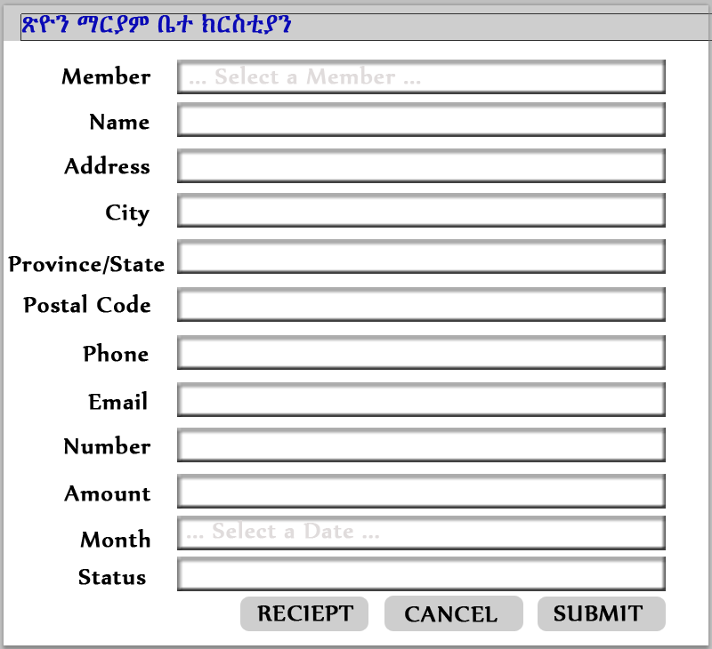

Stakeholder comments:

After viewing the designed form, can you give me specific ideas of what you have?

1. I need a page where I can choose to add new member, delete member, update member information.
   1. Add New Member (\*\*missing Member id)

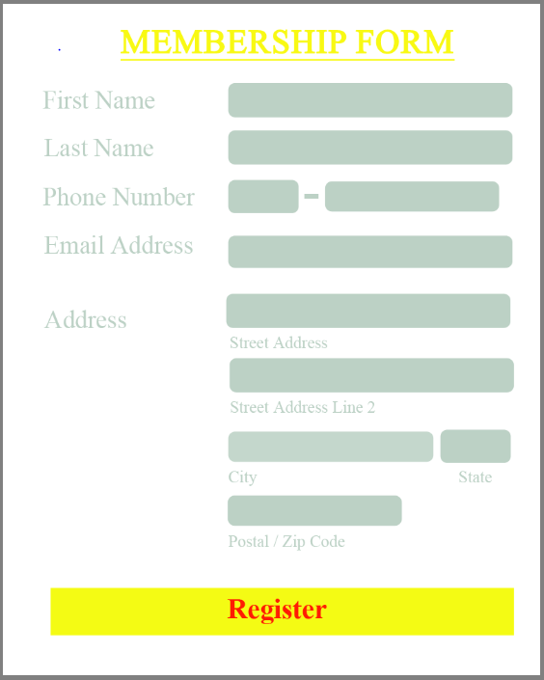

* 1. Update & Delete member Form

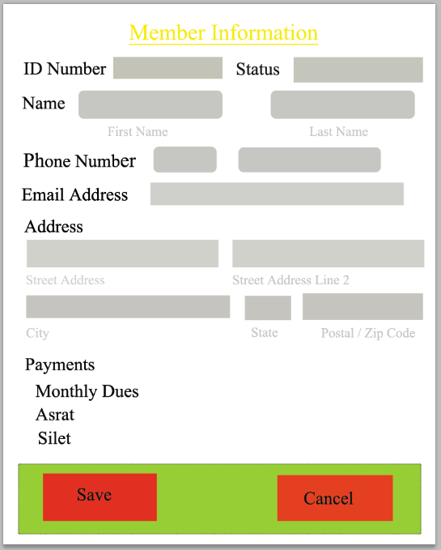

1. I need a log in page with username and password

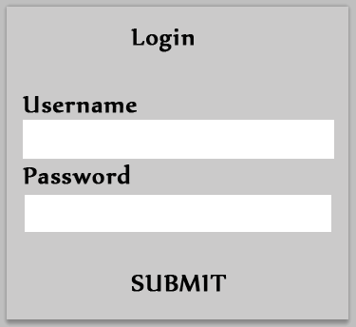

1. I need a page to submit membership payment

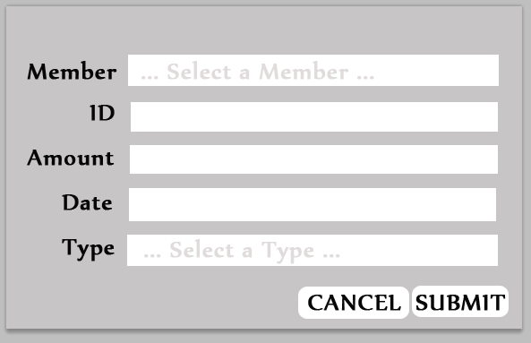

1. I need to run weekly, bi-weekly, monthly or annually report on:
   1. Membership List

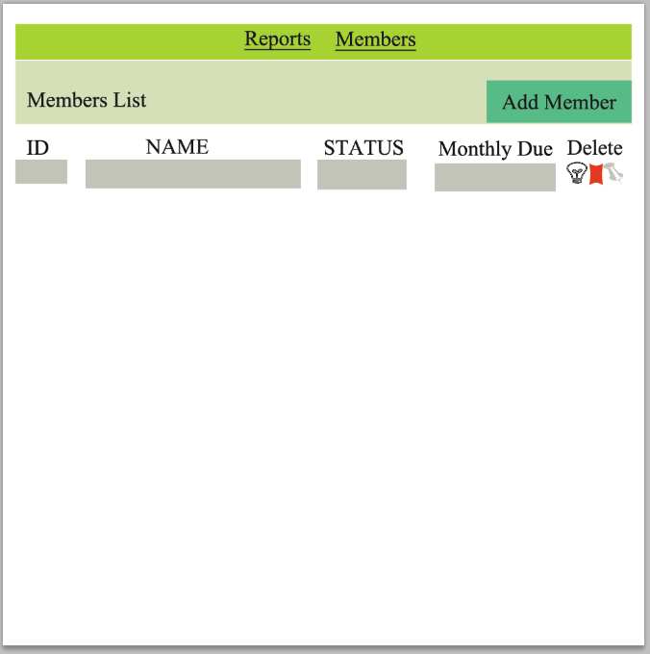

* 1. Membership Status
  2. Membership Payments
     1. Monthly Dues
     2. Asrat
     3. Silet
  3. report page to show existing members (search for member)